

**Open Post-doc position in the NANO-SPECTROSCOPY group**

The NANO-SPECTROSCOPY group of Prof. Marta De Luca in the Physics Department of Sapienza University of Rome is looking for a Post-doctoral researcher in the field of **advanced optical spectroscopy on nanostructured materials**.

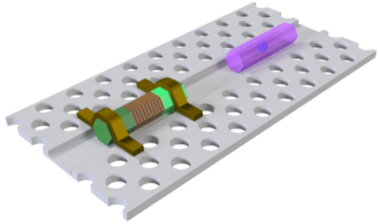Our project. The position is funded by the **ERC Starting grant** of M. De Luca, titled ‘NANO*WHY*R: Dots-in-NANOWires by near-field illumination: novel single-photon sources for HYbRid quantum photonic cir cuits’. The project aims at creating novel single photon sources integrated with Si-based photonic circuits. The main limitation of Si-based integrated photonic circuits is the lack of an efficient single photon source. NANOWHYR aims to overcome this limitation by creating new quantum dots in III-V semiconductor nanowires integrated with Si-based cavities. The creation will involve hydrogen irradiation and annealing through scanning near field optical microscope. Advanced quantum optics experiments, from the VIS range to telecom wavelengths will be also carried out.

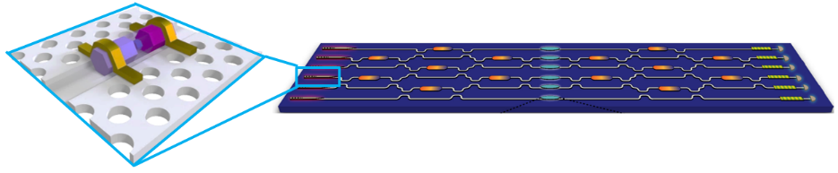

Your profile. Candidates with hands-on experience in optical spectroscopy (such as photoluminescence, or Raman, absorption, scanning near-field spectroscopy, g(2) measurements etc.) on nanostructures are encouraged to apply. Previous experiences with ultrafast lasers or detectors, and/or optical simulations, and/or clean room fabrication, and/or electrical measurements are also very appreciated.

What we offer. We offer an initial appointment of 1 year, with possible extension up to 3 years. You will be involved in inspiring international collaborations with materials scientists, theroetical and experimental physicists, and engineers all over the world.

Applications (including CV, list of publications and contact details of at least two referees) should be addressed by email to: Prof. Marta De Luca.